CSC262 Java Programming – Module 1 Assignment

First Name | Marco
Last Name | Aliaga
ID# | 900946024
Assignment Week# | 1
Email Address | m.aliaga6024@student.nu.edu

How to submit your Assignment
After filling all the parts in this file, please follow the following steps.
- Add your name and ID to the first page.
- Save the file in the original format (Docx or Doc)
(Please do not convert to other file formats e.g. PDF, ZIP, RAR, …).
- Rename the file as
YOUR First Name - YOUR Last Name- YOUR student ID- CSC262.docx

Example:
John – Smith - 234566435 – CSC262.docx
- Upload the file and submit it (only using Blackboard)
Please do not hesitate to contact your instructor for CSC262, should you have any questions.

Problem 1: Fuel Efficiency
Design a program that calculates the fuel cost per 100 miles and how far the car can go with a full tank of gas.
Your program needs to acquire the following inputs from the user: (1) the number of gallons of gas in the tank, (2) the fuel efficiency in miles per gallon, (3) the price of gas per gallon.
Your program needs to display the cost per 100 miles and how far the car can go with a full tank of gas.
Extra requirement:
- Your program must start with a display to the user what the program does.
- When acquiring the information from the user, your program must give clear instruction on what data the user should input and in what format (whole number or floating-point number).
- When displaying any monetary amount, your program must prefix the amount with $ and keeps exactly two digits after the decimal points.
- The variable names must be descriptive to the quantity they represent.
- The number of miles the car can go with a full tank of gas must be displayed as a whole number.
Your code for this problem
import java.util.Scanner;

public class fuelEff {

public static void main(String[] args) {

// Tell the user what this program is going to do
System.out.println("This program calculates the fuel cost per 100 miles");
System.out.println("and determines how far a car can go with a full tank of gas.");
System.out.println();

// Create a scanner so we can read input from the user
Scanner input = new Scanner(System.in);

// Ask the user for the number of gallons currently in the tank
System.out.print("Enter the number of gallons of gas in the tank (floating-point number): ");
double gallonsInTank = input.nextDouble();

// Ask the user for the car's fuel efficiency in miles per gallon
System.out.print("Enter the fuel efficiency in miles per gallon (floating-point number): ");
double milesPerGallon = input.nextDouble();

// Ask the user for the price of gas per gallon
System.out.print("Enter the price of gas per gallon (floating-point number): ");
double pricePerGallon = input.nextDouble();

// Calculate how many miles the car can travel with a full tank
double milesWithFullTank = gallonsInTank * milesPerGallon;

// Calculate how many gallons are needed to travel 100 miles
double gallonsFor100Miles = 100.0 / milesPerGallon;

// Calculate the cost to travel 100 miles
double costPer100Miles = gallonsFor100Miles * pricePerGallon;

// Display the calculated fuel cost per 100 miles
System.out.println();
System.out.printf("Cost per 100 miles: $%.2f%n", costPer100Miles);

// Display how far the car can travel with a full tank (whole number)
System.out.printf("Distance the car can travel with a full tank: %.0f miles%n", milesWithFullTank);

// Close the scanner since we are done getting input
input.close();
}
}

Run the code and insert the result in the following box.
Sample Run Result
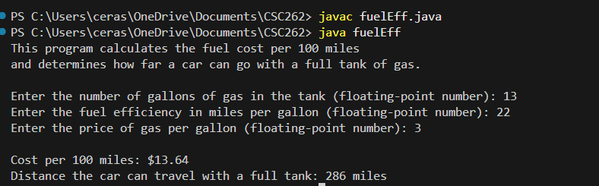

Problem 2: GPA Converter
In the CSC262 Course Outline, there is a Grade Table that shows the conversion from course grades in points to letter grades (A, A-, B+, etc.) and from letter grades to GPA number grade. Your instructor is responsible for assigning the course grades in points and converting them to letter grades. Please write a program that converts a letter grade into a GPA grade. If the user enters anything other than a valid letter grade, please display a descriptive error message before exiting the program.

Your code for this problem
import java.util.Scanner;

public class gpaConv {

public static void main(String[] args) {

// Explain what the program does
System.out.println("This program converts a letter grade into a GPA value");
System.out.println("and displays the corresponding percentage range.");
System.out.println();

// Create a scanner to read user input
Scanner input = new Scanner(System.in);

// Ask the user to enter a letter grade
System.out.print("Enter a letter grade (A, A-, B+, B, etc.): ");
String letterGrade = input.nextLine().toUpperCase();

// Variables to store GPA and percentage range
double gpa;
String percentageRange;

// Determine GPA and percentage range based on the letter grade
switch (letterGrade) {
case "A":
gpa = 4.0;
percentageRange = "94.00% to 100.00%";
break;
case "A-":
gpa = 3.7;
percentageRange = "90.00% to 93.99%";
break;
case "B+":
gpa = 3.3;
percentageRange = "87.00% to 89.99%";
break;
case "B":
gpa = 3.0;
percentageRange = "83.00% to 86.99%";
break;
case "B-":
gpa = 2.7;
percentageRange = "80.00% to 82.99%";
break;
case "C+":
gpa = 2.3;
percentageRange = "77.00% to 79.99%";
break;
case "C":
gpa = 2.0;
percentageRange = "73.00% to 76.99%";
break;
case "C-":
gpa = 1.7;
percentageRange = "70.00% to 72.99%";
break;
case "D+":
gpa = 1.3;
percentageRange = "67.00% to 69.99%";
break;
case "D":
gpa = 1.0;
percentageRange = "63.00% to 66.99%";
break;
case "D-":
gpa = 0.7;
percentageRange = "60.00% to 62.99%";
break;
case "F":
gpa = 0.0;
percentageRange = "59.99% and below";
break;
default:
// Handle invalid letter grades
System.out.println("Error: Invalid letter grade entered.");
System.out.println("Please enter a valid grade such as A, B+, C-, or F.");
input.close();
return;
}

// Display the final results
System.out.println();
System.out.printf("Letter Grade: %s%n", letterGrade);
System.out.printf("GPA Value: %.1f%n", gpa);
System.out.printf("Percentage Range: %s%n", percentageRange);

// Close the scanner
input.close();
}
}

Run the code and insert the result in the following box.
Sample Run Result
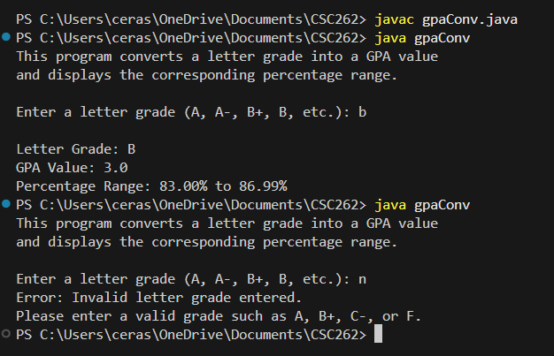

The end

